Esthetic utility and stem cell implication
of a new surgical procedure ALJ Technique

Pr.Dr. Abullatif A.H. Aljuboury

Abstract:
Introduction: the classic therapeutic surgical procedure could not follow the upstanding new esthetic demands with the utility of stem cell. The aim is to show the clinical utility of a new surgical technique out coming both values, therapeutic and esthetic purposes with the implication of stem cell.
Material and method: five cases of human adult subjects have been operated with the ALJ surgical procedure.
Results: full coverage of the surgical field with new healthy gingival tissues..
Discussion: Tissue engineering using mesenchymal stem cells (MSCs) is a recent therapeutic modality that has several advantages. MSCs have high proliferation potential and may be manipulated to permit differentiation before being transplanted, suggesting they may be an ideal candidate for regenerative procedures. The regenerative therapy needed a specific regenerative technique that allow the genetic factors to play their roles in finishing the outcome of the surgery
Conclusion: the ALJ technique showed to be clinically practicable with ability to activate gingival stem cells to achieve the specialization of the gingival tissues and giving a pleasant gingiva.
Key wards: stem cell, gingiva, esthetic surgery

المدخل: الطرق الجراحية التقليدية قد لا تتوافق مع متطلبات الجراحة التجميليه مع الاستخدام النفعي للخلايا الجذعية الموقفية الهدف من هذه الدراسة لتوضيح وعرض طريقة الانتفاع من التقنية الجراحية الحديثة (ع ل ج) لتحقيق كلا الفائدتين العلاج والتجميل في آن واحد.
المواد والتقنية: خمس حالات معالجة بالطريقة الجراحية ( ع ل ج) مع تحفيز للخلايا الجذعية الموضعية.
النتائج: الحصول على التغطية النسيجية الكاملة علاجيا وتجميليا.
المناقشة:الهندسة النسيجية التي تستخدم الخلايا الجذعية هي من الطرق المستحدثة والتي تحقق عدة فوائد ايجابية.الخلايا الجذعية (ا م اس سي) لديها قوة عالية للانقسام والتكاثر ومن الممكن التعامل معها لتسمح بالتكاثر السريع حتى قبل أن تنقل من موضعها مما يجعلها المرشح الأول للعملية التكوينية البنائية للأنسجة والتي كانت بحاجة إلى تقنيات خاصة لتنشيط العامل الجيني للعب دوره في إكمال المكاسب الجراحية.
الاستنتاج: تقنية البروفسور عبداللطيف الجبوري(ALJ) اطهرت سريريا إمكانية تنشيط الخلايا الجذعية الموقعية في اللثة وعظم الفك السخي لبناء الأنسجة وتعويض المتضرر منها وإعادة صحة وجمالية اللثة معا.

Introduction:
Since the fifties of last century a hundred of periodontal surgical techniques were provided and applied, mostly for therapeutic purposes, aimed to excise the over growth, regenerate the attachments or to maintain an acceptable dento-gingival relationship. Most of these basic techniques ended with a false successfulness or with some ugly gingival appearances. The scientist tried to inters artificial adjunctive substances, which are experimental first, then commercial and expensive, and need high surgical skill in order to improve a successful attachment and reduction in depth of the true pockets. Regenerative treatment of periodontal damaged teeth is a demanding task In addition to the appropriate flap technique and application of the regenerative materials, it requires to respect the basic rules: 1- performance of high quality oral hygiene control.2- to create a helpful dento-gingival relationship. 3- to maintain a healthy, pleasant, esthetic gingival appearance. 4- to eliminate as much as possible the anatomical defects that could be a risk for disease occurrence.
The aim of this study is to realize a clinical feature of the applicability and practicability of our new surgical procedure that gathers regeneration and esthetic purposes with local stem cell implication.
Material and methods:
Young adult subjects have been chosen having a multyfactoral gingival problem which could not been matches the indication of any known surgical technique.
Case one: female, young adult, 18 years old, systemically healthy, complaining from gingival enlargement with absence of attached gingiva on lower anterior segment with difficulty on brushing with no bone loss.
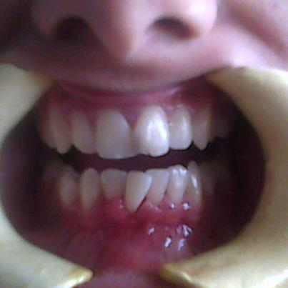
Case two: female, adult, 25 years old, systemically healthy, with gingival enlargement involving entire marginal, papillary and the insufficient narrow attached gingiva, extended up to alveolar mucosa and showing the impression of lips. no bone loss.
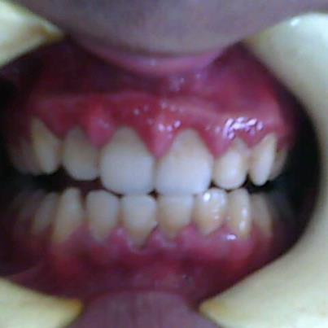
Case three: female, adult, 29 years old, systemically healthy, mal-aligned and mal-posted teeth, gingival enlargement. Thin, narrow and loose attached gingiva. Shadow of alveolar bone is clinically visible, slight bone loss around the mal-posted teeth.
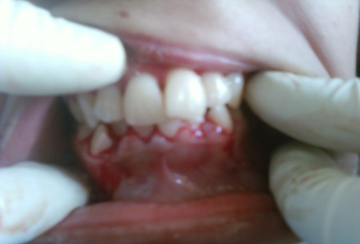
Case four: female, 31 years old, healthy, complete loss of attached gingiva, high lip lining attachment up to the gingival groove making a Diastema-like, incisors diverged and drifted.
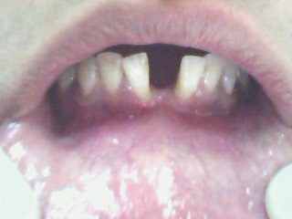
Case five: female, 15 years old, healthy, crowded teeth, gingival growth covering half length of teeth in both arches, complete loss of attached gingiva of lower anterior segments, slight horizontal bone loss, high and long maxillary frenal attachment, ugly looking.
TECHNIQUE:
Indications:
Narrow , insufficient or absent attached gingiva accompanied with gingival enlargement and associated with high frenal attachment that interfere or prevent proper brushing. When Gingivectomy alone is contra indicated. When apical replaced flap is contra indicated. When there shallow vestibule and gingival enlargement. When there is ugly alveolar compact bone. When there is horizontal bone loss with gingival enlargement. Horizontal moderate single or multiple gum recessions. Thin attached gingiva with possibility of future fenestration. Visible root eminences. For esthetic. For creation a protective attached gingiva. Facilitate personal home care.
Technical principles:
Customize the keratinized gingival tissues.
Internal beveled incision with variable angle degree depend on the gingival margin thickness.
Both side vertical or oblique incisions extended deeply toward the base of vestibule.
Reflect Mucoperiosteal flap including the enlarged gingival margin . The separation of the mucosal tissue must extend deeply up to the vestibular base.
Cut the muscular insertions around the surgical field. Remove the Frenum completely.
Create deep enough horizontal groove in the bony wall (1mm depth) to stabilize the recurrence of muscular fibers at the level of apical third of the roots.
Make to position the old marginal gingiva at the base of the vestibule.
Create a hung-up sutures, make it loose, suspended around the present teeth.
Create bleeding spots from the alveolar bone up to the cancellous spaces. Make the biological width around the teeth if necessary. Osteoplasty and bone crest remodeling if needed. plane the expose roots and that of biologic width.
Apply a suitable periodontal pack to adapt the flap and suture against the alveolar bone and make the suture be stretched.
Results:
All cases showed a suitable and healthy gingiva with a complete coverage of surgical field. The gingiva presented the anatomical characters of papillary, marginal and attached gingiva.
Case one:
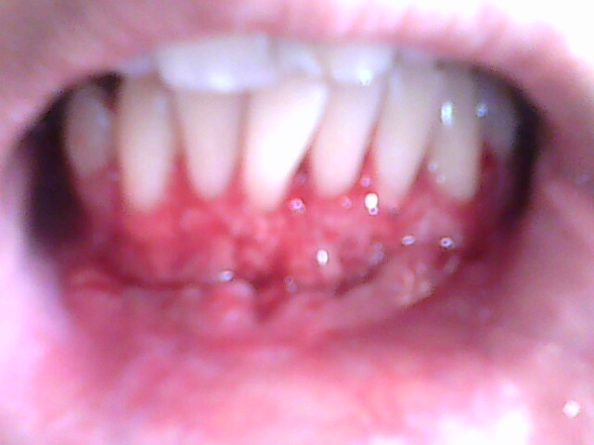
Before One week after surgery
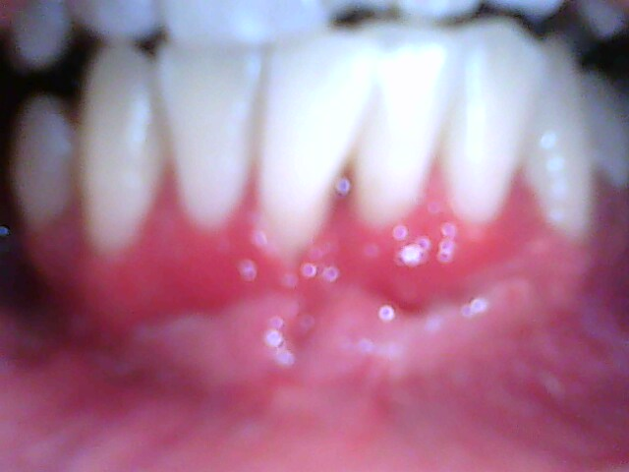
Two weeks after surgery..

Case two:
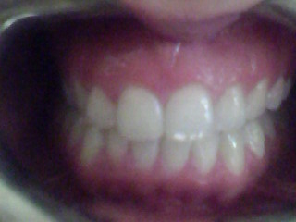
Before One month after surgery..
Case three:
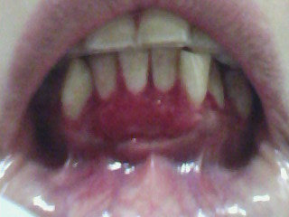
Before One week after surgery
Case four:
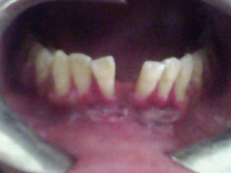
Before One week after surgery

Case five:
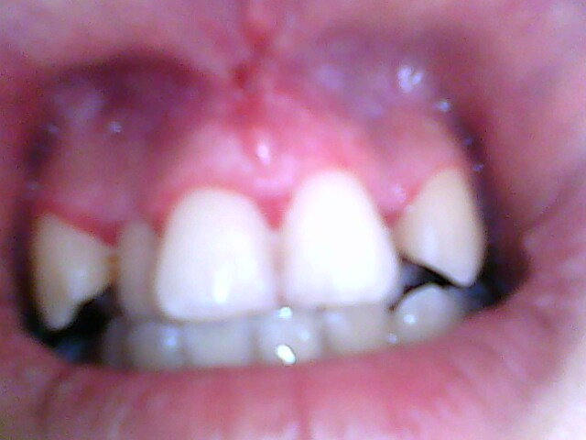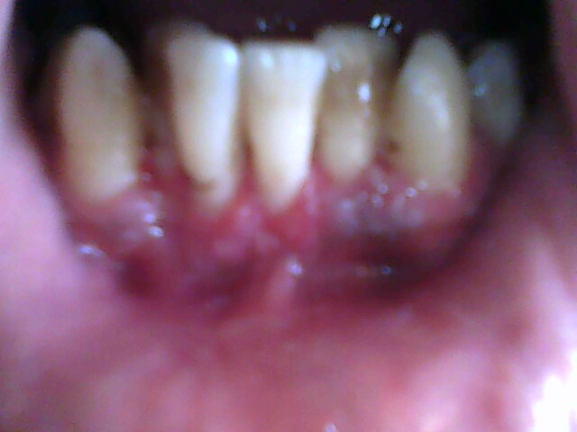
Two weeks after surgery, upper anterior One week after surgery, lower anterior segments. segment.

Discussion:
Recently the periodontal surgery doesn't just for therapy of damaged supporting structures, but also for esthetic and to facilitate daily oral hygiene procedure even the underlying structures is intact.
Some cases are simply treated with routine techniques, other could be more complicated and multyfactoral, a unique indication could not be suitable to realize the basic rules. Any technique has indications and contra-indication, even they have been routinely copied from generations, still adding limitation in use to match the needed result. However, limited success of these applications, along with the morbidity generated by some of them, has led medical science to seek alternatives that use biologic mediators to solve biologic problems.
Wound healing or the regenerative process in a speciﬁc tissue requires a combination of fundamental events, such as appropriate levels and sequencing of regulatory signals, the presence and number of progenitor cells that respond to the reparative signal⁽¹⁾
Tissue engineering using mesenchymal stem cells (MSCs) is a recent therapeutic modality that has several advantages⁽²⁾. MSCs have high proliferation potential and may be manipulated to permit differentiation before being transplanted, suggesting they may be an ideal candidate for regenerative procedures^{.(3)} Precise identiﬁcation of cells capable of regenerating the periodontium is valuable because no predictable regeneration procedure has yet been described⁽⁴⁾. (MSCs) have several advantages, These include high-quality regeneration of damaged tissues without forming ﬁbrous tissue, cells capable of self-renewing at a high rate of proliferation, and differentiating into multiple cell lineages including mesodermal, endodermal, and ectodermal⁽⁵⁾ MSCs have been isolated from different oral tissues cells, periodontal ligament, and dental papilla derived cells and alveolar bone marrow ⁽⁶⁾. Their participation in maintaining and repairing those tissues has been proposed. Thus, similarities with skin in structure and cell populations would hint that similar progenitor populations could exist in gingival connective tissue^{.(7)} This idea is consistent with the oral tissues’ ability to repair without scars, reﬂected by a minimal inﬂammatory response^{(8).} Consequently, the identiﬁcation and characterization of stem cells present in the gingiva tissue could give valuable information about the function and regenerative potential of this tissue to be applied in regenerative therapy⁽⁹⁾. The regenerative therapy needed a specific regenerative technique that allow the genetic factors to play their roles in finishing the outcome of the surgery^{(10).} ALJ procedure appeared useful, practicable, giving excellent clinical result, able to create a suitable protective gingiva with functional and healthy dento-gingival relationship. Indeed it needs a high surgical skill of the operator. Healing taking normal duration in young-adult and adult subjects with two weeks packing. Stem cell activation and specialization looks great, creating attached, marginal and papillary gingival tissues.

References:
1- Tomas I. M, Melisa S. G, Flavio C.E, et.al. Culture and Characterization of Mesenchymal Stem Cells From Human Gingival Tissue. Periodontol, 2010;81:917-925.
2- . Sudo K, Kanno M, Miharada K, et al. Mesenchymal progenitors able to differentiate into osteogenic, chondrogenic, and/or adipogenic cells in-vitro are present in most primary ﬁbroblast-like cell populations. Stem Cells 2007;25:1610-1617.
3- Fang W, Meijiao Y, Xinlong Y, et.al. Gingiva-Derived Mesenchymal Stem Cell-Mediated Therapeutic Approach for Bone Tissue Regeneration. Stem Cells and Development. December 2011, 20(12): 2093-2102.
4-Gronthos S, Akintoye SO, Wang CY. et.al. Bone marrow stromal stem cells for tissue engineering. Periodontol 2000, 2006;41:188-195.
5- . Stephens P, Genever P. Non-epithelial oral mucosal progenitor cell populations. Oral Dis 2007;13:1-10.
6- Kolf CM, Cho E, Tuan RS. Mesenchymal stromal cells. Biology of adult mesenchymal stem cells: Regulation of niche, self-renewal and differentiation. Arthritis Res Ther 2007;9:204-214.
7- Cesselli D, Beltrami AP, Rigo S, et al. Multipotent progenitor cells are present in human peripheral blood. Circ Res 2009;104:1225-1234.
8- Ohta S, Yamada S, Matuzaka K, et.al. The behavior of stem cells and progenitor cells in the periodontal ligament during wound healing as observed using immuno-histo-chemical methods. J Periodontal Res 2008;43:595-603.
9- Park BW, Hah YS, Choi MJ, et al. In-vitro osteogenic differentiation of cultured human dental papilla-derived cells. J Oral Maxillofac Surg 2009;67:507-514
10- Zhou Y, Hutmacher DW, Sae-Lim V. Osteogenic and adipogenic induction potential of human periodontal cells. J Periodontol 2008;79:525-534.
……………………………………………………………………………………………………………………………………………….
* ALJ: professor doctor Abdullatif A.H. Aljuboury. PhD, Periodontology, University cloud Bernard, Lyon, France
- Professor of oral and periodontal surgery, University of Baghdad, Iraq
- Chairman of dentistry college, Humanities University, An-najaf, Iraq.

